AN E-LEARNING MANAGEMENT SYSTEM WITH REINFORCEMENT LEARNING ALGORITHM FOR TERTIARY LEVEL OF COLLEGE OF ST. CATHERINE QUEZON CITY

A Thesis Presented to the Faculty of the

Information and Communications Technology Program

STI College Caloocan

In Partial Fulfilment

of the Requirements for the Degree

Bachelor of Science in Computer Science

Elaijah Mae A. Caragdag

Lian Andrei O. Tapales

Tobby B. Villaneuva

June 2024

ENDORSEMENT FORM FOR DEFENSE

TITLE OF RESEARCH: AN E-LEARNING MANAGEMENT SYSTEM WITH REINFORCEMENT LEARNING ALGORITHM FOR TERTIARY LEVEL OF COLLEGE OF ST. CATHERINE QUEZON CITY

NAME OF RESEARCHERS: Elaijah Mae A. Caragdag

Lian Andrei O. Tapales

Tobby B. Villanueva

In Partial Fulfilment of the Requirements

for the degree Bachelor of Science in Computer Science

has been examined and is recommended for Defense.

ENDORSED BY:

Mr. Jesus Laxamana

Thesis Adviser

APPROVED FOR DEFENSE:

Mr. Bernard Mendiola

Thesis Coordinator

NOTED BY:

Mr. Bernard Mendiola

Program Head

June 2024

# APPROVAL SHEET

This thesis titled: AN E-LEARNING MANAGEMENT SYSTEM WITH REINFORCEMENT LEARNING ALGORITHM FOR TERTIARY LEVEL OF COLLEGE OF ST. CATHERINE QUEZON CITY prepared and submitted by Elaijah Mae A. Caragdag; Lian Andrei O. Tapales; and Tobby B. Villanueva, in partial fulfillment of the requirements for the degree of Bachelor of Science in Computer Science, has been examined and is recommended for acceptance an approval.

Mr. Jesus Laxamana

Thesis Adviser

Accepted and approved by the Thesis Review Panel

in partial fulfillment of the requirements for the degree of

Bachelor of Science in Computer Science

|  |  |
| --- | --- |
| <Panelists' Given Name MI. Family Name> | <Panelists' Given Name MI. Family Name> |
| Panel Member | Panel Member |

<Panelists' Given Name MI. Family Name>

Lead Panelist

Noted:

|  |  |
| --- | --- |
| Engr. Bernard Mendiola | Engr. Bernard Mendiola |
| Thesis Coordinator | Program Head |

June 2024

# Table of Contents

|  |  |  |
| --- | --- | --- |
|  | | Page |
| Title Page | | i |
| Endorsement Form for Thesis Defense | | ii |
| Approval Sheet | | iii |
| Table of Contents  List of Figures  List of Table | | iv  v  v |
| Introduction | | 1 |
|  | Background of the problem | 1 - 5 |
|  | Overview of the current state of technology | 5 |
|  | Objectives of the study | 5 - 6 |
|  | Scope and limitations of the study | 7 - 10 |
| Literature Review  Foreign Literature  Local Literature | | 11 |
|  | Review of related literature, studies, or systems | 11 - 20 |
|  | Synthesis | 20 - 21 |
| An e-learning management system with reinforcement learning algorithm for tertiary level of College of St. Catherine Quezon City | | 22 |
|  | Methodology | 22 - 24 |
|  | Hardware/Software | 25 - 27 |
|  | Calendar of Activities | 28 - 29 |
|  | Budgetary Estimate | 30 |
| References  Appendices | | 31 - 32  33 - 58 |

|  |
| --- |
| LIST OF FIGURES |

|  |  |  |
| --- | --- | --- |
| Figure |  | Page |
| 1 | Methodology – Agile | 22 |
| 2 | Conceptual Framework of the System | 24 |
| 3 | Data Flow Diagram | 51 |
| 4 | Cumulative Flow Diagram | 52 |
| 5 | Flowchart | 53 |
| 6 | Entity Relationship Diagram | 54 |
| 7 | HIPO Diagram | 55 |
| 8 | Login Page | 57 |
| 9 | Dashboard | 57 |
| 10 | Profile | 58 |
| 11 | Subjects | 58 |
| 12 | Messages | 59 |
| 13 | Announcements | 59 |
| 14 | Logout | 60 |
| 15 | Survey | 61 |

LIST OF TABLES

|  |  |  |
| --- | --- | --- |
| Table |  | Page |
| 1 | Hardware Requirements | 25 |
| 2 | Software Requirements | 26 |
| 3 | Gantt Chart | 29 |
| 4 | Budgetary Estimate | 30 |

Introduction

           The global education landscape is undergoing a tremendous transformation driven by the digital age. The emergence of e-learning, or "electronic learning," offers a solution through web-based courses, online platforms, and various other tools that leverage technology to enhance student knowledge and skills (Santiago, C. S. et al., 2021). E-learning utilizes the capabilities of the internet and digital resources to provide accessible, engaging, and customizable education catered to individual student needs.

E-learning has become a well-established and progressive educational option for schools worldwide. According to Jagadamba G. et al. (2020), it offers an alternative to traditional classroom methods by providing a variety of delivery formats, including online courses, virtual classrooms, and interactive apps. These formats have gained popularity among students comfortable with technology. The flexibility, convenience, and student autonomy in controlling their learning pace are transforming education. However, this transformation necessitates further examination of the implications for our educational landscape.

**Background of the problem**

The College of St. Catherine Quezon City (CSCQC) prides itself on offering a range of educational programs from preschool to college degrees and TESDA courses. However, the current learning methods employed at the institution primarily rely on traditional classroom tools like blackboards or whiteboards, supplemented by annual textbook distribution for various subjects. While these resources are certainly available, the responsibility falls solely on the students to acquire notebooks for note-taking and keep pace with the instructor's teaching speed.

This research delves into the effectiveness of these traditional approaches. The core concern lies in whether students are fully utilizing the provided resources to effectively support their learning. The investigation aims to identify any shortcomings in the current system and explore potential improvements.

The research identified limitations associated with the traditional methods currently in place. While there's no denying the value of these approaches, they cannot fully capture student attention and foster a deep engagement with the learning material. This can potentially lead to a less-than-ideal learning experience, hindering students' motivation and overall academic performance.

To gain valuable insights into these limitations and student experiences, researchers surveyed tertiary students under the supervision of Mr. Carlo Serapio. The survey specifically targeted 33 tertiary students enrolled at CSCQC.

The survey findings revealed interesting data regarding student preferences and experiences with traditional learning methods. While a significant portion of the student body (over 42%) expressed satisfaction with the overall learning experience despite the absence of a Learning Management System (LMS), and nearly 58% found course materials readily accessible, a considerable number (around 30%) remained neutral on the overall accessibility of technology for educational purposes within the school.

An even more noteworthy finding was that nearly half the students (48.4%) felt the lack of an LMS hindered their ability to effectively track deadlines and stay organized. Interestingly, an equal percentage (48.5%) believed that implementing an LMS would significantly enhance their overall learning experience. This suggests a strong student preference for a more technology-integrated learning environment. However, it's important to note that another nearly half (48.5%) reported feeling engaged and motivated despite the limitations of the current system. This highlights the potential for further improvement while acknowledging the effectiveness of traditional methods for some students.

Based on the research findings and identified limitations, the researchers propose the development of an electronic Learning Management System (eLMS) to supplement the existing traditional learning methods. An eLMS has the potential to address the shortcomings identified in the current system and create a more well-rounded learning experience for students. The proposed system offers several advantages. It can provide a more engaging and interactive learning environment, fostering deeper student participation and potentially leading to increased motivation. 

The elms would streamline workflow for teachers by allowing them to distribute assignments, quizzes, and other materials electronically. This would also simplify student progress tracking, enabling instructors to provide more targeted support when needed. Students would benefit from access to a wider range of learning materials and resources beyond traditional textbooks and notebooks. The potential for digital resources within the elms could reduce costs associated with purchasing new notebooks and textbooks every year.

The development of an elms at CSCQC presents a valuable opportunity to address the limitations of traditional methods and create a more engaging and effective learning environment for both students and faculty. By incorporating technology into the educational experience, CSCQC can empower students to take a more active role in their learning journey and foster a deeper understanding of the taught subjects.

**General Problem**

The researchers analyzed the information collected from interviews with tertiary students to discuss their struggles regarding the lack of an electronic Learning Management System (LMS).

**How to develop an E-Learning Management System with Reinforcement Algorithm for Tertiary Level of College of St. Catherine Quezon City?**

Considering the challenges faced by the College of St. Catherine in Quezon City, such as students' lack of engagement in lectures, manual grading of papers, and the absence of data-driven insights, the researchers conclude that the development of an e-learning management system is necessary to address and resolve these issues. To achieve this, the researchers propose setting SMART goals, which stand for specific, measurable, achievable, relevant, and time-bound objectives. These goals will guide the creation of a module within the e-learning management system that enables students to access lectures and take quizzes. By establishing these SMART goals, the researchers can ensure a clear, focused, and achievable plan for developing an e-learning management system module that meets specific requirements and enhances students' overall learning experience.

**Specific Problems**

1. **How to develop a module that allows students to read lectures and take quizzes?**

The objective is to develop an accessible interface that lets students access lecture materials, including presentations, documents, and videos, and a separate quiz section. The module should provide tools such as progress tracking for lectures and a user-friendly interface for quizzes, which will include multiple-choice and short answer questions. Additionally, instant feedback should be provided to students upon answering a question.

1. **How to develop a module that allows students to submit/upload assignments after the due dates using virtual coins?**

To address this challenge, a rule should be established that permits late submissions within a predetermined grace period. Furthermore, a mechanism should be implemented where digital awards or incentives are withheld from late submissions and given to those who submit their assignments on time. The module should include a friendly submission interface that clearly explains the late submission policy, along with details about the associated digital incentives. By solving these difficulties, an electronic learning management system can provide a comprehensive learning experience that encompasses engagement, assessment, and rewards for student participation and accomplishments.

1. **How to develop a module that awards virtual coins to students after they complete a quiz?**

The main objective is to create a reward system that distributes virtual coins based on the student's performance, accuracy, or progress in the quiz. This system should be seamlessly integrated with the quiz module so that prizes are automatically assigned upon completion of the quiz or according to predetermined performance indicators.

**Overview of the Current State of the Technology**

The field of education is continuously evolving with the integration of technology. Presently, many institutions heavily rely on E-Learning Management Systems, which serve as digital platforms designed to enhance the effectiveness, engagement, and accessibility of teaching and learning. These systems enable instructors to deliver lessons efficiently while utilizing various tools and resources within the system.

Based on the survey conducted with 33 students at the College of St. Catherine in Quezon City, the majority of their responses indicated a neutral satisfaction level with their learning experience. While they expressed contentment with the teaching methods employed by their instructors, such as using tools like PowerPoint, images, and videos, the ratings for implementing a learning management system to enhance their overall learning experience were significantly high (83.87%). This suggests that most students acknowledged the need for improvements in certain aspects of their learning experience, such as tracking deadlines or due dates and enhancing engagement during lessons. The remaining percentage (16.13%) did not provide a specific rating. 

This study's purpose is to enhance teaching tools and methods to encourage student engagement during lectures and facilitate better understanding of the lessons through an e-learning management system. Instructors will be able to share their lessons, monitor students' progress, and utilize engaging videos to make learning more interesting. Students, on the other hand, will have the flexibility to study individually or collaboratively, regardless of their location, as long as they have an internet connection.

**Objectives of the study**

The main objective of the research is to develop “An E-Learning Management System with Reinforcement Learning Algorithm for Tertiary Level of College of St. Catherine Quezon City”. An E-Learning Management System that will elevate the students’ learning experiences, minimizing the difficulties that the students usually dealt with.

**General Objective**

**An E-Learning Management System with Reinforcement Algorithm for Tertiary Level of St. Catherine of Quezon City**

The general objective of this research is to conduct a comprehensive investigation into the role and impact of E-Learning Management Systems within the student’s education. With a reinforcement learning algorithm, personalized learning pathways can be created through adaptive learning, which modifies the educational process in response to a student's interactions and performance. The study seeks to understand the broader effectiveness, challenges, and prospects for improvement in the utilization of e-learning management systems as a key technological component in modern learning environments.

**Specific Objectives**

1. **To develop a module allowing students to read lectures and take a quiz**

In this module, the researchers will create an accessible user-friendly interface where students can access lectures and quizzes, ensuring it is intuitive and easy to navigate. This is where also will allow the instructors to upload lecture materials in various formats such as PDFs, videos, and slideshows and create quizzes with different question types like multiple choice, true or false, and essays that will satisfy both users, the students, and instructors.

1. **To develop a module that will allow the student to submit/upload assignments after due dates using virtual coins**

 The system will send an automated notification to students reminding them of upcoming deadlines. If there is any interference or problems with the students’ submission, they can use the virtual coins to persuasively submit their assignments that went past on due dates. In this case, the system will notify instructors that a student has submitted an assignment late using wild coins thus the instructors allowing the students’ late submission. By offering digital incentives for late submissions, instructors can encourage students to stay involved in their schoolwork even if they miss the original deadline. It is imperative to achieve a balance between boosting punctuality and allowing legitimate excuses for late submissions to uphold fairness.

1. **To develop a module that rewards the student with virtual coins after taking a quiz**

Developing this module will automatically grade the students’ quizzes and provide instant feedback that includes showing correct answers and explanations for incorrect inputs upon students’ completion. Additionally, the researchers added a feature where if the student finishes the quiz, the system will analyze the data, and depending on the score, the student will receive a reward which is the wild coins, this coin allows the student to progress and to be engaged while take the following quizzes.

**Scope and limitations of the study**

This study is about implementing an e-learning management system that encompasses user management, course creation, content delivery, communication tools, assessment and grading, reporting, and security features to facilitate efficient online learning.

* The system will be exclusively available as a web application for Android, iOS, and Microsoft Windows operating systems.
* The system has been meticulously tailored to cater exclusively to tertiary students, positioning them as the primary beneficiaries, as its purpose is to function as a supplementary learning aid, enabling them to access comprehensive modules and enhance their studies.
* The system comprehensively encompasses all topics and subjects taught in schools, ensuring that students have access to a wide range of educational materials and resources.
* The system boasts cross-platform compatibility, allowing users to access its features and resources seamlessly across various devices and operating systems.
* The system will exclusively implement quiz formats such as multiple-choice and essay questions, offering students a diverse range of assessment methods to evaluate their understanding and critical thinking skills.
* Internet Connectivity will be implemented to ensure seamless integration and timely tracking of their progress, module updates, and diligently monitors students' progress over time.

**Scope**

**Back End**

**1.1 Log-in module**

In the login module, the researchers will need the list or record of the students that were enrolled so they can create an account for that student and also an account for the staff and teachers. Those who were enrolled will have access to the student’s e-learning management system. To access their accounts, the students and teachers will enter the email and password that was given by the admin of the school. 

**1.2 Attendance module** In the attendance module, the researchers will add a feature where teachers can check or monitor the attendance of their students. The attendance will be updated and the teacher will receive a notification every time their students access the module of that subject in the class.

**1.3 Assessment module**

In the assessment module, the student’s assessment grades will change depending on their scores and identify their improvements. The assessment score will be updated every time they finish a quiz, activities, and task performance. 

**1.4 Message notification module**

In the message notification module, this is a feature where students and teachers can communicate with each other through the use of the e-learning management system.

**1.5 Upload lessons, quizzes, activities, and task performance module**

In this module, teachers are permitted to upload their subject’s handouts, quizzes, activities, and task performance that will be complied by their students.

**Front End**

**2.1 Subject module**

In the subject module, each subject will have its module that consists of lessons, activities, quizzes, and task performance every quarter. The students will be able to access the handouts and answer or do the task that was given by their teacher anywhere. 

**2.2 Seatwork/Quiz Module**

In the seatwork/quiz module, teachers can give seatwork or quiz and post it on the e-learning management system. 

**2.3 Message notification module**

In the message notification module, this is a feature where students and teachers can communicate to each other through the use e-learning management system.

**2.4 Announcement module**  

In the announcement module, this is the feature where students will receive announcements about events, suspensions, and updates from the staff and admins of the school. 

**2.5 Mail notification module**  

            The mail notification module is another feature where students receive mail from the registrar about the update of their forms and documents like scholarships, grades, payments, etc.  

**2.6 Calendar module**

The calendar module is where students can check the dates of the events, school activities, and deadlines of their assignments.

**Limitation**

* **Other school levels**
* Elementary
* Highschool
* Senior Highschool
* **Payment Methods**
* **Multiple Login Accounts**

Literature Review

Review of related literature, studies or systems

The Literature review is a review of related literature, studies, or systems that are related to E Learning Management System with Reinforcement Learning Algorithm for Tertiary Level of College of St. Catherine of Quezon City. The researcher’s key points in this literature are: learning management system, blackboard, and google form.

*The Impact of E-Learning Apps on Child’s Mental Agility*

Berrocoso J. V. et. al (2020) The Researcher presents a systematic literature review (SLR) to analyze the growth of educational research on e-learning and to identify the most relevant theories, the research topics, and the most researched models. The study is based on a literature review and the findings and results rest based on 249 literature reviews. The author found three main modalities of e-learning and they were students, teachers, and interactive curriculum. Massive Open Online Course was the most accessed modality in current period. Thus, it can be concluded that E-learning studies and interactive learning environment oriented towards research is carried out in higher education and teaching learning emphasis on self-regulated learning. It deals especially with the progress of learning management system.

Lara, J. A. et al., (2020) The author explores the new trends in e-learning assessment through a systematic literature review. Different approaches in the study that are explored are block-chain techniques, gamification, the mining process, and many more. Thus, it can be concluded that E-learning environment, design, analyses and interpretation contribute to new skills and knowledge and encourage advance implementation of software and hardware approaches with development of learning assessment

Baz, F. Ç. (2018) The research paper emphasizes on the new trends that are trending in the world of e-learning. The concept of e-learning in the field of education leads to speedy progress. In this study, the concepts AI, Virtual and augmented reality, big data concept, blended learning modes, cloud computing learning through games, m-learning, IoT, video.

*E-Learning Personalization Systems and Sustainable Education*

Sustainable education development is described as human, cultural, ethical, and ecological principles in the context of higher education with the intention of providing societies with good practices that enable greater competitiveness and better growth of organizations, institutions, and communities, hence confirming awareness of and enhancing social and economic life Bush, (2019); Singh, (2019). Stakeholders prioritize transparency of the long-term sustainability of educational institutions’ activities Hill & Lawton, (2019). As a result, long-term management will be required to adopt management systems that are based on digital, open, networked, and innovative institutions Cristina, et. al., (2019).

Quality education presents one crucial part of the future of the quality of human life and the world’s long-term sustainability. New digital technologies are transforming education in both formal and informal learning contexts. Some of the most significant aspects and how they are affecting education should be considered Tejedor, et. al., (2019).

Personalization elements place a strong emphasis on personal growth and learning environments. Learners’ personal growth of knowledge and skills gained via Internet communities and online courses is the emphasis of personal development. A personalized learning environment involves a variety of services, learning tools, and applications built tailored to the needs of individuals based on Web 2.0 or Web 3.0 elements, such as lower-cost teaching, enhanced user capabilities, and the creation of a personalized student profile Samah, et. al., (2020).

*Learning Management System (LMS) Use with Online Instruction*

In online classroom environments, LMS reinforces teachers and students in the learning process. A standard LMS supports an inclusive learning environment for academic progress with interceding structures that promote online collaborative-groupings, professional training, discussions, and communication among other LMS users Al-Fraihat, et. al., (2020); Dias & Dinis, (2019); Jung & Huh, (2019). Since the advent of online learning in the mid/late 1990s, the technology and tools which support online learning structures continue to progress Kehrwald & Parker, (2019). LMS compositions include a variety of media and communications tools and promote learner choice Kehrwald & Parker, (2019).

When selecting an LMS, school organizations can choose a proprietary system or open-source system Kimmons, et. al., (2019). The decision depends on the resources available and the knowledge or level of expertise of members within school organizations (Turnbull, et al., 2019). A proprietary system uses an exclusive code where schools purchase a license or subscription to access and use the LMS features (Kimmons, et al., 2019). Open-source systems use a free license with no cost where users have the freedom to access and use the system Kimmons, et al., (2019); Quinn & Gray, (2020); Turnbull, et al., (2019).

As students learn to use LMS features, they can assess their learning progress better Alkhasawnh & Alqahtani, (2019); Islam N., (2019). As a strategy, learners can commit and use an LMS to work collaboratively on educational learning assignments Dias & Dinis, (2019). As practitioners use an LMS within an online learning climate, consideration should go towards levels of interactions with students, supporting learners’ ICT associates, and facilitating further professional development.

Teachers’ beliefs can impact decisions made within an online environment Jung & Huh, (2019). A teacher’s ideas can influence decisions with curriculum processes of implementation to support online academic success Jung & Huh, (2019). In online environments, instructors use LMSs to facilitate and model discussions, plan online activities, set learning expectations, provide learners with choices and options, and assist learners in solving problems and making decisions Jung & Huh, (2019).

*Adaptive E-Learning Authentication and Monitoring*

Jagadamba G. et al., (2020) E-learning enables the transfer of skills, knowledge, and education to a large number of recipients. The E-Learning platform tends to provide face-to-face learning through a learning management system (LMS) and facilitates an improvement in traditional educational methods. The LMS saves organization time, and money and easy administration. LMS also saves users time moving across the learning place by providing a web-based environment. However, a few students could be willing to exploit such a system's weakness in a bid to cheat if the conventional authentication methods are employed. In this scenario, user authentication and surveillance of end users is more challenging. A system with simultaneous authentication is put forth through multifactor adaptive authentication methods. The proposed system provides an efficient, low-cost, and human intervention adaptive for e-learning environment authentication and monitoring system.

*Students’ perception of E-Learning: A Basis for the development of E-Learning framework in higher education institutions*

Daniels M. M. et al., (2019) As learnings styles evolve along with modernizing society, educational technology also expands. A current trend in education brought about by technological advances is the e-learning system where teachers and students can discuss lessons online and exchange learning resources. This study explored on the areas of e-learning and provided a review on current e-learning frameworks from different studies. A recent study of Debattista presented a comprehensive rubric for e-learning and it is adopted by this paper as basis for gathering student expectations, feedback, and problems encountered in e-learning. These rubrics were rated by students according to importance. Statistical findings show a significant difference between ratings of students from public and private institutions. Similarly, there is a significant difference between the ratings of male and female students. The difference might spring from the level of interest of students towards learning as factored in by type of institution and gender. Students’ learning expectations in an e-learning environment were also gathered in this study as a basis for a proposed e-learning framework. All specific standards presented by Debattista were labelled very important by respondents and are therefore adopted into the proposed framework. Along with these rubrics are proposed additional standards that focus on the enrichment of student experience and enhancement of learning. It is still highly recommended that strict and proper implementation of such standards are supervised by concerned administrative departments.

*Learning Management Systems (LMS) towards helping teachers and students in the pursuit of their E-Learning methodologies*

Lee, C. M. (2021) Education Sector in the Philippines has been successful by means of integrating the E-Learning LMS with Schools, Colleges, and Universities, because of the conventional educating and learning techniques with its pivoted scholastic schedules. One thing which advanced E-Learning development approaches becomes effective during these questionable occasions was the appropriation of instruction innovations by most establishments to restart and make due adjustments. Likewise, different organizations were prospered, and instructive establishments received E-Learning devices to give schooling through internet learning more excited. Virtual stages of lead classes, and by openness to E-Learning substance and AI-empowered delegating devices, consoled the societies to work consistently in a computerized way. E-Learning programs have been accessible to guardians to help the learning of their students for some time now. Proper training for example Schools and College frameworks have been utilized LMS as the essential learning and business arrangement or computerized arrangement for them. Instructors utilized E-Substance learning and recordings as reference materials, with innovation combination kept to PC labs online.

*Amidst the Online Learning Modality: The usage of learning management system (LMS) and its relationship to the academic performance of the Filipino students*

Tus, J. et al., (2021) To increase student performance and learning, today's technology-driven society and academic institutions embrace Information and Communication Technologies (ICTs), leveraging learning management systems (LMS), and adopting blended learning methodologies. Thus, this study investigates the relationship between the usage of a learning management system and academic performance among 188 Filipino senior high school students. Based on the Pearson correlation coefficient, there was no relationship between LMS usage and the students' academic performance.

*Filipino students experience in Online Learning: A Meta-Synthesis*

Conocono, A. S. et al., (2023) This study presented a meta-synthesis of Filipino students' experiences in Online Learning. It utilized 15 out of 1090 studies from 2021 to 2022 that were screened through inclusion and exclusion criteria. The studies were organized using the Preferred Reporting Items for Systematic Reviews and Meta-Analysis (PRISMA) 2020 flow diagram and were quality-checked using the Critical Appraisal Skills Programme (CASP) checklist for systematic review. Clark and Braunes' six-step thematic analysis was done and has emerged seven themes: mental and emotional barrier, social interaction barrier, lack of availability of gadgets and intermittent internet connections, lack of financial support, attention span and academic performances, and parental involvement in an online class. Students' experiences in online learning emerged as the meta-theme of the study. Filipino students' experiences in online learning opened up new avenues for new ways of learning but a lack of resources and training makes it difficult for them to learn. It is recommended that students should join a free online symposium that tackles various coping mechanisms amidst distance learning. Academic Institutions must provide adaptive learning systems and the Philippine Government must address the issues and concerns in distance learning.

*Flexible learning adaptabilities in the new normal: E-Learning resources, Digital meeting platforms, Online learning systems and learning engagement*

Santiago, C. S. et al., (2021) The COVID-19 pandemic has forced the educational systems to shift from traditional learning to flexible learning. Flexible learning is a combination of digital and non-digital technology that ensures the continuity of inclusive and accessible education in the form of online, offline, or blended modes of teaching and learning processes. This descriptive study determined the learning tools and e-learning resources, learning platform and online learning systems, skills towards learning platform and online learning systems, and learning engagements of students of Cavite State University - Silang Campus (CvSU-SC) amidst the new normal setting of learning. Using stratified random sampling, there were 364 student-respondents represented by four departments who answered the structured questionnaire online using Google Form. The findings revealed that smartphones and mobile applications were the most utilized educational tool and e-learning resources. Google Classroom was the most widely used online learning system during asynchronous classes, while Google Meet was a meeting platform during synchronous scheduled classes. It was found that students' skills towards online learning systems and meeting platforms were proficient. During flexible learning, Facebook was on top of the most convenient, followed by Google and Zoom as perceived by students as accessible, equitable, communicative, monitorable, and sustainable to use. Consequently, it was found that students strongly agreed on preparedness as the most vital to engagement in online learning. Accordingly, findings suggest that strengthening online teaching and delivery of methods by creating content tailored to the needs of the students during flexible learning will propel to ensuring the efficacy of teaching and learning processes. Various suggestions were offered for key players in education in addressing the challenges of online learning.

*E-Learning Technology Adoption in the Philippines: An Investigation of Factors Affecting Filipino College Students' Acceptance of Learning Management Systems*

According to Garcia, Manuel (2017), the Philippines' education system has been plagued by the same problems and challenges, notably with regard to its logistical setup, from a lack of instructional resources, facilities, and even schools to underpaid but overworked teachers. Nevertheless, education is still highly valued in Filipino culture, and it is frequently cited as the greatest equalizer of opportunity.

The purpose of this study is to identify the factors that influence students' acceptance of e-learning technologies, specifically learning management systems in the Philippine context. Data collected from 629 Filipino college students using SEM techniques were analyzed using the AMOS structural equation modeling method. The subjects of this study are Filipino students enrolled in higher education courses, which are considered a priority in Philippine education. As such, it has practical and technical implications for local and global educational environments and can be used by educational leaders, educational technologists, educators, and learners. These influences can help in the development, implementation, and deployment of e-learning technologies such as LMS.

*Using Google form for Student Worksheet as Learning Media*

Teachers mostly used papers in surveys, activities, and tests, making it difficult for them to organize the papers efficiently in some colleges. Today, thanks to technological advancements, physical learning or face-to-face learning can be translated into online learning. The obstacles they experience can be overcome with the help of Google Forms, which includes several sorts of forms that can be used to help teachers save time and money while also making learning engaging and entertaining. Iqbal, Muhammad, et al. (2018)

The purpose of this research is to explain the process for creating student worksheets using Google Forms, as well as the types of worksheets created. It employs qualitative descriptive approaches with teachers serving as study subjects. Observation, in-depth interviews, and an examination of numerous document sources are used to collect data. The research explains the phases of planning, designing, and implementing student worksheets using Google Forms. It generates a variety of worksheet models, such as narrative, audio-visual, and link models. The study also examines past research on the usage of Google Forms in education. The study suggests that using Google Forms to create student worksheets improves accessibility, engagement, and efficiency in the learning process. The study's findings highlight the importance of using Google Forms to create interesting and dynamic learning environments while saving time.

*The Application of Google Classroom as a Tool for Teaching and Learning*

According to Izwan Nizal Mohd Shaharanee, et al. (2016), this focuses on the integration of Google Classroom into data mining and associated applications teaching and learning in higher education. Its goal is to use the Technology Acceptance Model (TAM) which is a theoretical framework that helps in understanding and predicting users' acceptance and adoption of new technologies to evaluate the effectiveness of Google Classroom's active learning activities. The method used for the study included providing a questionnaire to 100 students enrolled in the data mining subject, followed by analysis using TAM to investigate the association between identified characteristics and the effectiveness of the learning activities. Students are generally satisfied with Google Classroom's performance as an active learning tool, particularly in areas such as ease of access, perceived utility, communication and involvement, instruction delivery, and overall satisfaction, according to the findings.

*Evaluation of usability in Moodle Learning Management System through Analytics Graphs: University of Applied Sciences Teacher’s perspective in Finland*

Teachers and administrators can track and assess student performance and activities within the Moodle Learning Management System (LMS) using the Moodle Learning Analytics tool, particularly the Analytics Graphs. The tool gives information about students' activities, such as logins, total time spent within the online learning system, engagement in various activities, idle time, and the purpose of their Moodle login. It also enables for group performance analysis, comparison of average time spent in Moodle by different groups, and prediction of reasons for students' good or poor performance. Sunday Olaleye, et al. (2023).

The Analytics Graphs can help educators monitor and track students' interactions on the Moodle platform, providing insights into student progress, involvement, and submissions. This data can be utilized to improve classroom education, improve the e-learning experience, and influence retention rates and student achievement. Overall, the Moodle Learning Analytics tool, especially the Analytics Graphs, is critical in providing important insights into student performance and activities inside the LMS, ultimately helping to the improvement of teaching and learning processes.

*The Effectiveness of Blackboard System Uses and Limitations in Information Management*

The blackboard system now has a recognized presence in the information management of the education system. According to Olson & Bruner (2020), “the acquisition of knowledge as the primary goal of education can be seriously questioned." There are models of education in the information age, such as Blackboard, which assesses students’ existing knowledge level, shares course materials databases, supports collaboration (teacher-student, student-student, teacher-teacher), and evaluates learner goals and performance to maximize the effectiveness of the institutions.

In conclusion, it appears that Blackboard is a useful LMS that promotes pedagogical gain and constructivist perspectives. Blackboard provides a collaborative and user-friendly environment for teaching and learning in terms of communication, assessment, and the overall information management system.

*Assessing the Impact of Online-Learning Effectiveness and Benefits in Knowledge Management, the Antecedent of Online-Learning Strategies and Motivations: An Empirical Study*

The effectiveness of online learning depends on many factors, including student and instructor self-efficacy, attitudes, and confidence in using the technology involved; the educational strategies employed; the ability to monitor and evaluate educational outcomes; and student motivation, among many others. In this study, we analyzed how these factors were associated and impacted each other. We developed a comprehensive model after an extensive review of the relevant literature. The model was validated by applying partial least square regression to the data obtained by surveying 469 students who were enrolled in online education. The test results indicated that all the variables had a positive effect on the effectiveness of online learning.

Synthesis

The synthesis of the study is at present times efficiency and productivity with the least amount of work and expense are the most, just like with software applications. Instead of the work being done by the software itself, the development of software opens up more opportunities for you to spend more time developing and innovating. As Electronic Learning Management System (E-LMS) emerging and has already been implemented in many universities and institutions.

Through a deep investigation into new trends, such as adaptive authentication, gamification, and flexible learning adaptabilities, the studies indicate that the potential for customized and interactive learning is tremendous. E-learning platforms are capable of supporting diverse learning styles and needs, potentially leading to improved academic outcomes. This research should continue to monitor the progression of E-Learning tools and methodologies, recognizing the dynamic nature of technology and its impact on education.

sssssssssssssssssssssssssssssssssssssssssssssssssssssssssssssssssssssssss

E-learning Management System with Reinforcement Learning Algorithm for Tertiary Level of College of St. Catherine Quezon City

In this section, we take a closer look at the technical details of how we will create the system and put it into action. We will explore the different stages to make it work. Additionally, this section gives an overview of the system design specifications, which means it outlines the rules and limits for how the system should operate.

*Figure 1. Agile Method*

Agile Software Development

With Agile’s iterative approach, researchers can continuously test and refine their work, enabling them to identify potential issues and fix them before they escalate into significant problems. This iterative process reduces the likelihood of defects and enhances the overall quality of the system. Furthermore, regular feedback and reviews from stakeholders and customers ensure that the product’s development aligns with their requirements and the project’s goals.

1.1 Plan

In the planning stage, the researchers will conduct a process of identifying, evaluating, and ranking its needs and goals. The researchers will also identify possible hazards and difficulties that could arise throughout development. It will also establish deadlines and goals to direct the project.

1.2 Design  
 In the design stage, the researchers will carefully organize in accordance with the needs determined during the planning phase. While gathering data from the instructor and students, the researchers will develop the user interface, design the gameplay, and lay out the overall architecture of the system. The researchers will also ensure that the finished design satisfies St. Catherine College's unique requirements.

1.3.Develop  
 In the development stage, the researchers will build the system with an agile methodology emphasizing iterative development and frequent testing. The researchers will work in brief intervals, or sprints, with the goal of completing a predetermined set of features, testing them, and resolving any issues before going on to the next sprint.

1.4.Test  
 In the testing stage, the researchers will thoroughly evaluate the developed system to make sure it fits the requirements specified in the planning phase and operates as intended. Unit, integration, and system tests will all be a part of this testing process, which will try to find and address any problems before proceeding to the deployment stage.

1.5.Deploy  
 In the deployment stage, the system will be presented to the client with the researchers' help. In order to ensure a seamless implementation for the students, The client will get a briefing to acquaint himself with the e-learning management system. To make sure the system is performing as planned, careful observation will be done.

1.6 Review  
 In the review stage, the client will go over the system in detail to identify any potential improvements. Future iterations of the e-learning management system will be improved based on the insightful input he offers, guaranteeing that it will always satisfy the needs of the school and the students.

1.7.Launch   
 After the system is released to the school, the researchers will closely monitor its performance and gather input from teachers and students. To make sure the system is successfully addressing the needs of the school, this continual check is being conducted. The researchers will also make sure it incorporates the most recent technology advancements and undergoes routine maintenance and updates to ensure it keeps functioning properly.

PROCESS

OUTPUT

INPUTT

*Figure 3. Conceptual Framework*

**H**ardware and Software

Hardware Requirements

|  |  |
| --- | --- |
| Hardware | Requirements |
| Processor | Intel® Core ™ i3-10105 CPU 3.70GHz |
| Memory | 8gb |
| Graphics Card | DirectX 12 |
| Peripherals | Monitor: 75hz  Mouse: A4 Tech  Keyboard: A4 Tech |
| Language | English (Default Language) |

*Table 1. Hardware Requirements*

Software Requirements

|  |
| --- |
| Software |
| MongoDB |
| Visual Studio Code |
| JavaScript |
| Node JS |
| Web Browser |
| GitHub |
| Canva |
| Figma |

*Table 2. Software Requirements*

In this project, a learning management system database architecture must be able to collect and link information about courses, course categories, students, course enrollments, teachers, classes, attendance, tests, and scores. Once this information is in a database, you may query it to retrieve relevant statistics and analytics such as attendance rates per course and by instructor, pass rates, and score averages. While visual studio code will be the foundation of the system. This is where the backend of the system will be created. The programming language that will be used is JavaScript as for its versatility and being one of the most used languages for developing web pages and web applications. Web browser play a crucial role in the creation and use of web applications. It will serve as the runtime environment for the implementation of the said project, providing the necessary infrastructure for rendering, interaction, communication, and security. The researchers leverage these capabilities to create cross-platform, interactive, and feature-rich web applications. On the other hand, Canva and Figma will be used for detailing and is a source of designs for the user interface that will be constructed.

Calendar of Activities

The thesis was created in the second week of September, and the researchers submit some viable subject schemes in the third week of September. We are grateful to our thesis supervisor for making this happen to have our title approved by the second week of September. Following permission, the researchers began work on Chapter 1. Researchers was given a client on the same day where the title was approved, and by the next week, the interview with the clients had begun. After gathering enough material, the researchers finalized and completed Chapter 1 by the second week of December. The researchers went on to create Chapter 2 before they even finalized their Chapter 1. The researchers’ tasks were allocated within the first week of November, and each researcher had a separate job. Researchers were able to complete Chapter 2 by the last week of October thanks to their hard effort. Researchers continue to work on Chapter 3.

**Gantt chart of Activities**

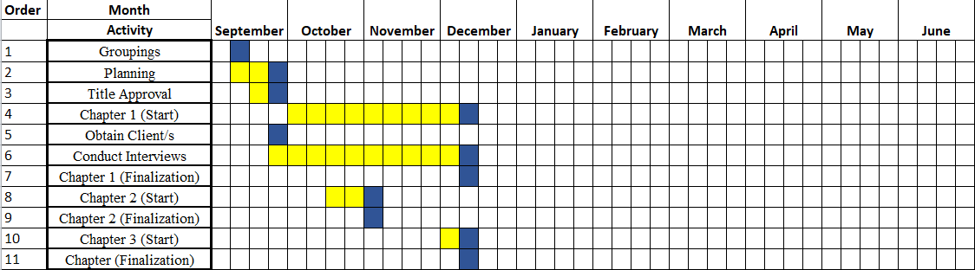Table 3. Gantt Chart

**Budgetary Estimate**

|  |  |
| --- | --- |
| Specifics | Approximate Cost |
| Personal Computer x 2 | 78,000 |
| Internet Connection | ₱1,200/Month |
| Documents | ₱500 |
| Transportation | ₱2,500 |
| Waiver | ₱1,708 |
| Others | ₱1000 |
| Web Hosting | ₱5000 |

*Table 4. Budgetary Estimate*

The researchers used two (2) personal computer that costs a total of ₱78,000. Each researchers have their own internet connection that roughly estimates to ₱1,200 monthly. The overall documents cost ₱500. While the transportation cost over ₱2,500, this value was already estimated each of the researchers’ transportation fee. The researchers were also required to pay an amount of ₱424 each for the thesis defense and was estimated over ₱1,708. Other fees were collected and amounts over ₱6000.

LOCAL LITERATURE

|  |  |  |  |  |
| --- | --- | --- | --- | --- |
| 1 | E-Learning  Personalization  Systems and  Sustainable  Education | Personalized learning material or tool with the use of the internet. | Personalized learning material that has features, tools, and others that can be used with or without the internet like when you download the handouts. | Can be used with or without the internet as long as you download the handouts. |
| 2 | Learning  Management  System (LMS)  Use with Online  Instruction | Compositions include a variety of media and communications tools and promote learner choice. | Uses media, has a communication feature, and has the modules and handouts that the students will need. | The difference is that the Elms that they developed make the learners choose what subject they want. The elms that were being created by the proponents have a module already that was given based on the course they took. |
| 3 | Adaptive E-  Learning  Authentication and Monitoring | Saves users time moving across the learning place by providing a web-based environment. | Has a feature where students can only access another module by using the elms points, they get from answering quizzes and activities. | Does not need to open different tabs and websites since everything is already provided by the system even the communication. |
| 4 | Students’ perception of E-Learning: A Basis for the  development of E-Learning framework in higher education institutions | Teachers and students can discuss lessons online exchange learning resources and apply the rates of the students that were presented to enhance the learning experience of the students. | Has a chat system where students and teachers can communicate or even make a group chat where they can post announcements. | The difference is that the first one discusses lessons online while the other which is created by the proponents is that every student and teacher can communicate with each other about other things as well and announce things online. |
| 5 | Using Google form for Student Worksheet as  Learning Media | Has forms where anyone especially the teachers can make their quizzes and activities. | Gives access to teachers to make their quiz and post it in the elms so students can answer it. | The difference is that Google Forms allows everyone to make their quiz while in Elms, only teachers can make it. |
| 6 | The Application of Google Classroom as a Tool for Teaching and Learning | Forms can be used in different ways. It can also be used in doing surveys. | Teachers can only use it to make quizzes and activities, not surveys and others. | Forms can be used in almost everything that can be answered by everyone while Elms is only for educational purposes. |
| 7 | Evaluation of Usability in Moodle Learning  Management System through Analytics Graphs:  University of  Applied Sciences  Teacher’s perspective in  Finland | Gives information about students' activities, such as logins, total time spent within the online learning system, engagement in various activities, idle time, and the purpose of their Moodle login. | Has a feature where teachers can monitor and track the student’s performance that has a leaderboard, the purpose of logging in, and the module they opened or viewed. | Both have the same feature which is tracking and monitoring most of what the students were doing once they logged in. The only difference is that there is a top 10 leaderboard of students that has the most points in each subject and section. |
| 8 | The Effectiveness of Blackboard System, Uses and  Limitations in  Information  Management | The Blackboard system allows the instructors to generate and gather content and resources according to their lessons, the module was divided into weekly portions. | The elms allow the instructors to change or follow the lessons and modules that were given by the school in each subject and course. | The difference is that for the students to access the next module, they have to use the Elms points that they received from answering quizzes and activities that were given to them by their instructors. |
| 9 | Assessing the  Impact of Online-  Learning  Effectiveness and  Benefits in  Knowledge  Management, the | Online learning helps students to learn more about computers and allows them to expand their knowledge by accessing their | Allows the students to access their handouts to study anywhere as long as they have an internet or data connection or they downloaded the | Elms allows the students to study inside and outside the school with or without the internet just by downloading the handouts they need. |

FOREIGN LITERATURE

|  |  |  |  |  |
| --- | --- | --- | --- | --- |
| 10 | Learning  Management  Systems (LMS) towards helping teachers and students in the pursuit of their e-learning methodologies | Accessible to teachers to help the learning of their students. | Both teacher and student can access the system but the purpose of the system is different from one another. | Both can be accessible to students and teachers but the difference is that when the teachers or instructors log in to their account they’ll see the modules of the subject they teach, check the works of their students, and view their performance. |
| 11 | Amidst the  Online Learning Modality: The usage of a learning management  system (LMS)  and its  relationship to the academic performance of Filipino students | This is about learning the relationship between the LMS to the academic performance of an ICT student. | The research of the proponents is about the enhancement of the student’s learning experience through the use of elms. | The first one is about the relationship of Elms to the students while the other one is about how Elms will be used to help the students in learning. |
| 12 | Filipino students experience in Online Learning:  A Meta-Synthesis | Is about conducting an analysis about distant learning | Is about creating or developing a system where students can still learn by accessing their elms whenever or wherever they are. | The difference between the two is that the first one is about an analysis that may affect the student in distant learning especially when pandemic started while the other one is about how Elms can be used by students anytime, anywhere to study. |
| 13 | Flexible learning adaptabilities in the new normal: E-Learning resources, Digital meeting platforms, Online learning systems and learning engagement | They used different platform and mobile applications as an educational tool and e-learning resources. | A system where every learning material is already added like handouts, PowerPoint and others. | The difference is that in Elms, they do not need to use any other platform besides Google to learn since most of the things that was needed by a student were in Elms. |
| 14 | E-Learning  Technology  Adoption in the  Philippines: An  Investigation of  Factors Affecting  Filipino College  Students'  Acceptance of  Learning  Management  Systems | This study is about the influence of students’ acceptance of e-learning technology due to the problems and challenges they experience like lack of resources, facilities, etc. | The system will help the students since it can be used anytime and is web-based so even on their phones they can access it. | The first one addresses the influence of challenges on students' acceptance of e-learning technology, while the second one focuses on the advantages of the e-learning system's accessibility. |
| 15 | Canvas Adoption  Assessment and  Acceptance of the  Learning  Management  System on a  Web-Based  Platform | Is a web- and cloud-based platform that allows the users or students and staff to communicate face-to-face in real-time, dashboards, and assessment tools incorporate an application that lets the instructors view the submissions of the students and grade it. | Elms is a web-based platform that students can use and understand easily because of the dashboards, module, calendar where you can check the due date of the assignments, and a graph that shows well the performance of the student in that subject. | The difference is that students who use Elms get notified about announcements of due dates and let the instructors or the students themselves check their performance just by looking at the graphs. |
| 16 | Usability  Evaluation of  Online Learning Management System:  Blackboard,  Google | This system lets the instructors track students' participation and evaluate their performance | Elms allows for evaluation of the performance of the student. | The difference is that Google Classroom, canvas, and Blackboard allow users to communicate with each other face-to-face online while Elms only allows the users to communicate with each other through chat. |
| 17 | Students  Perception and  Satisfaction of  Google Classroom as  Instructional  Medium for  Teaching and  Learning | Satisfies the students as a tool for flexible learning since it has features that support communication, interaction, and instruction delivery which is easy to use and understand. | Allows the students to communicate with each other through the messaging system and has rubrics that were created by the school or the instructor themselves. | Students cannot make or take a call using Elms since it only supports a messaging system, unlike Google Classroom where students and teachers can make a call. |
| 18 | Interactive  Learning  (iLEARN) Tool: An eLearning  Portal Designed  Using MOODLE  for Cagayan State  University in the  Philippines | Allow the students and instructors share information, collaborate and interact with each other inside and outside the classroom, manage the exams and scores, and grade the students. | Allow the students to interact and have ideas with the instructors inside and outside the school and grade the exams and scores of the students. | Elms does not let the students collaborate with the others since they can only answer activities and quizzes by their selves. |
| 19 | Blended E-  Learning  Management  System for the  Technological  University  Graduate  Programs | Allows the students to learn even in synchronous or asynchronous at the same time depending on the schedule of the student. | Asynchronous and synchronous work depends on the student they want to alone or with others anytime wherever they are. | The difference between the two is that if a student cannot attend a regular class, they would need to install or use another app or website since Elms does not support video calls. |

**REFERENCES**

Al-Busaidi, K., & Al-Shihi, H. 2010. "Instructors’ Acceptance of Learning Management Systems: A Theoretical Framework". Communications of the IBIMA, 2010, pp. 1–10. <https://ibimapublishing.com/articles/CIBIMA/2010/862128/>

Bradley, V. M. (2021). Learning Management System (LMS) use with online instruction. International Journal of Technology in Education (IJTE), 4(1), 68-92. [https://doi.org/10.4632 8/ijte.36](https://doi.org/10.4632%208/ijte.36)fiel

Ivanović, M., & Klašnja-Milićević, A.(2021). E-learning personalization systems and sustainable education. Sustainability, 13(12), 6713. <https://www.mdpi.com/journal/sustainability/special_issues/elearning_personalization_systems_and_sustainable_education>

Khiccha, P. K., Solanky, M., & Soni, S. (2020). The Impact of E-Learning Apps On Child’s Mental Agility. International Journal of Research in Engineering, Science and Management, 3(9), 174–181. Retrieved from <https://journal.ijresm.com/index.php/ijresm/article/view/321>

Noori, N.M. & Ozdamli, F., & Saleem, A.N.(2022). Gamification Applications in Elearning: A Literature Review. Tech Know Learn 27, 139–159. [https://doi.org/10.1007 /s10758-020-09487](https://doi.org/10.1007%20/s10758-020-09487)

G. Jagadamba, K. C. Rohini, K. N. Brinda, R. Sheeba, & S. K. Pratik, "Adaptive ELearning Authentication and Monitoring," 2020 2nd International Conference on Innovative Mechanisms for Industry Applications (ICIMIA), Bangalore, India, 2020, pp. 277- 283, <https://ieeexplore.ieee.org/document/9074955>

Cruz, J. D, Daniels, M., & Sarte, E. T. (2019). Students’ perception on e-learning: a basis for the development of elearning framework in higher education institutions. IOP Conference Series, 482, 012008. [https://doi.org/10.1088 /1 757- 899x/482/1/012008](https://doi.org/10.1088%20/1%20757-%20899x/482/1/012008)

Lee, C. M. (2021). Learning Management Systems (LMS) towards helping Teachers and Students in the pursuit of their E-Learning...ResearchGate. <https://www.researchgate.net/publication/350287112_Learning_Management_Systems_LMS_towards_helping_Teachers_and_Students_in_the_pursuit_of_their_E-Learning_Methodologies>

Cruz M. A., Espiritu, N. A., Paras, N. E, & Tus, J. (2021). Amidst the Online Learning Modality: The Usage of Learning Management System (LMS) and Its Relationship to the Academic Performance of the Filipino Students. Int. J. Psychol. Behav. Sci, 11, 9-12 <https://www.researchgate.net/publication/356912130_Amidst_the_Online_Learning_Modality_The_Usage_of_Learning_Management_System_LMS_and_Its_Relationship_to_the_Academic_Performance_of_the_Filipino_Students>

Aying, F. L., Cabanilla, A., Canillo, J., Capangpangan, A., & Conocono, A. S. (2023). Filipino Students Experiences in Online Learning: A Meta-Synthesis. International Journal for Research in Applied Science and Engineering Technology, 11(3), 1181–1189. <https://doi.org/10.22214/ijraset.2023.49511>

Santiago, C. J. (2021, December 31). Flexible learning adaptabilities in the new normal: E-Learning resources, digital meeting platforms, online learning systems and learning engagement. <http://www.asianjde.com/ojs/index.php/AsianJDE/article/view/580>

Learning Management System. (2016, May 22). [Slide show]. PPT. <https://www.slideshare.net/ShubhamSingh527/learning-management-system-62278633?fbclid=IwAR3GfY3yBwP3yaR4oE2gKSdjiE0OlYrNaBE616eew8UKVar4SNIUB_K1ODI>

E Learning Management System by Tuhin Roy using PHP. (2020, April 16). [Slide show]. PPT. <https://www.slideshare.net/TuhinRay2/e-learning-management-system-by-tuhin-roy-using-php>

eLearning Company Blog & eLearning Company Blog. (2023, November 25). The Pros and Cons of eLearning without a Learning Management. . . The eLearning Blog. <https://elearning.company/blog/the-pros-and-cons-of-elearning-without-a-learning-management-system/>

Faisal, F. (2018). Using Google form for Student Worksheet as Learning Media. Faisal. https://doi.org/10.31227/osf.io/u49y6

Open Campus, The University of the West Indies, West Indies. (n.d.). International Journal of Education and Development using ICT - Vol. 19, No. 3 (2023). http://ijedict.dec.uwi.edu/viewarticle.php?id=3113

**APPENDICES**

Appendix A: Inquiry Letter/ Consent Forms

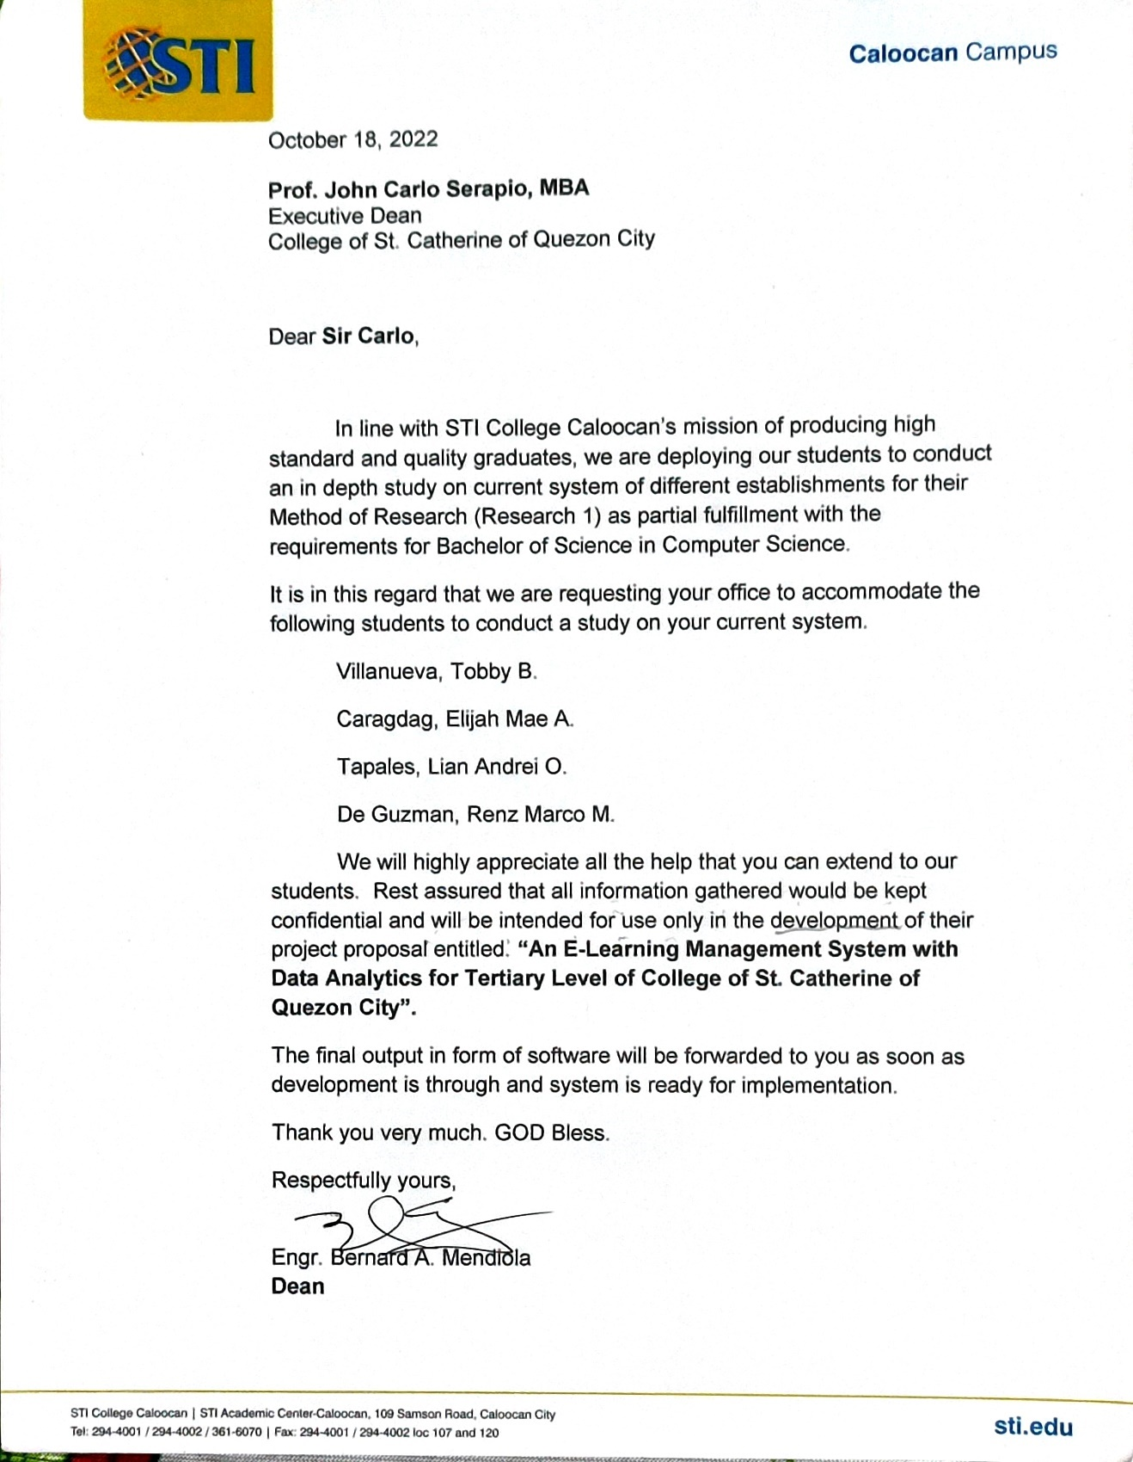

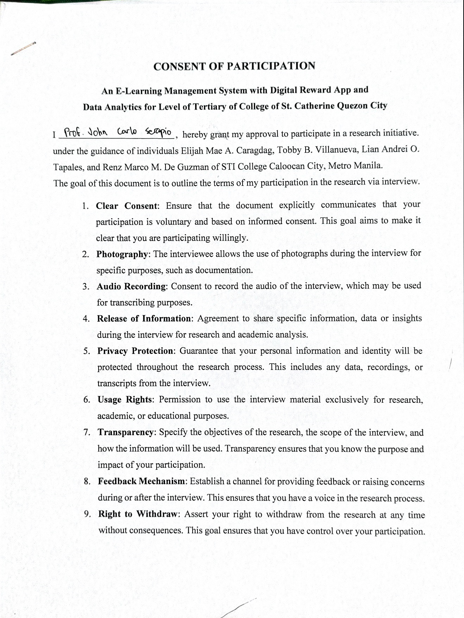



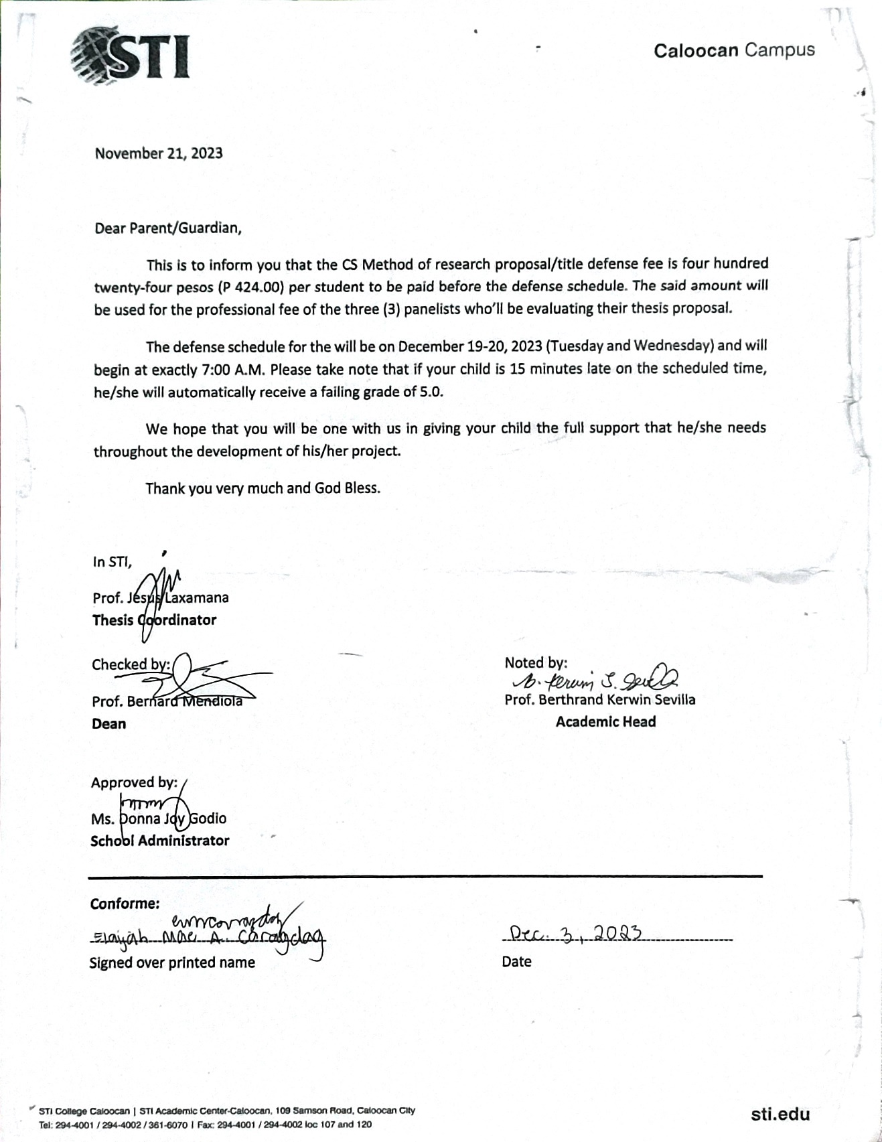

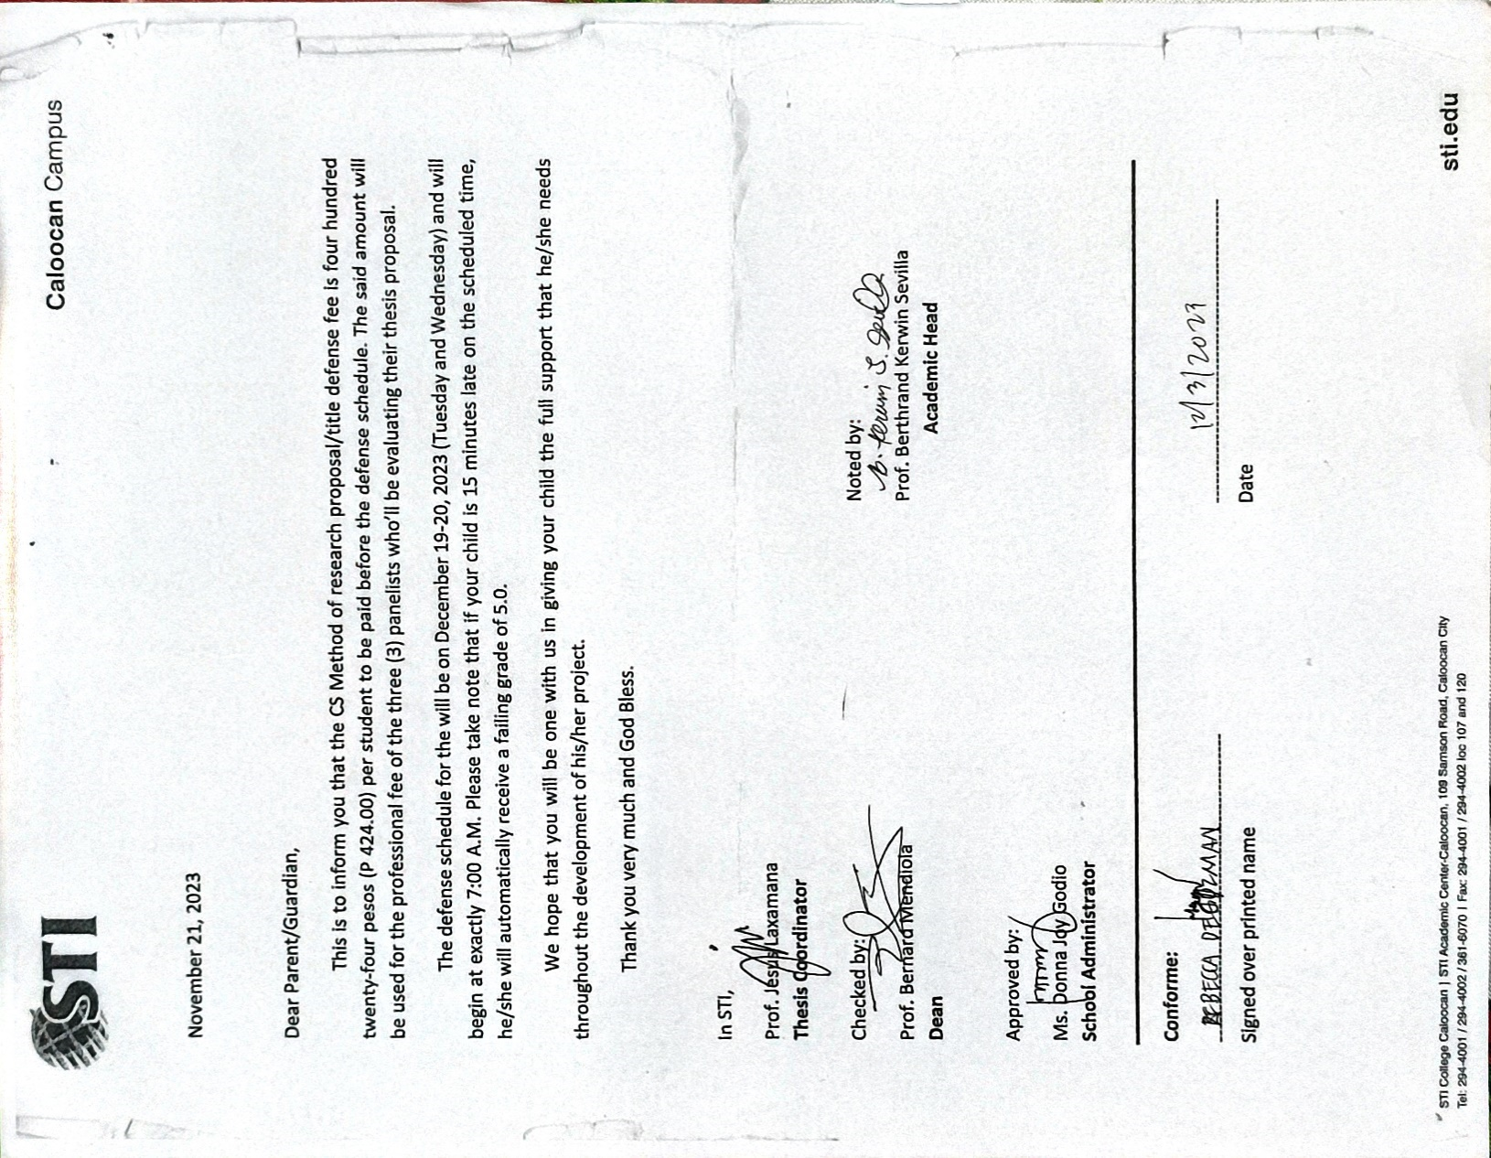

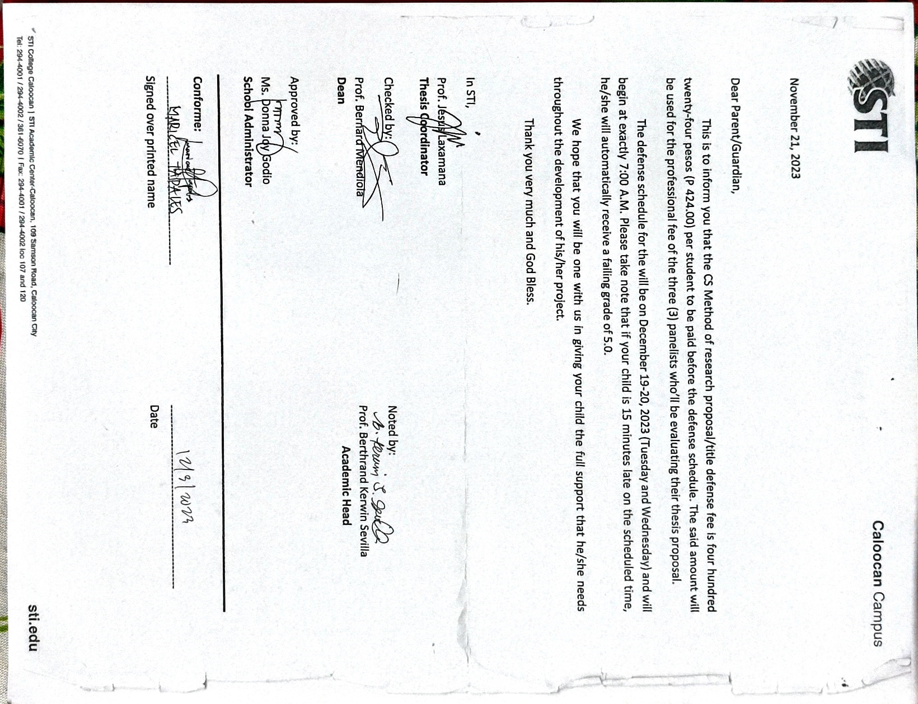

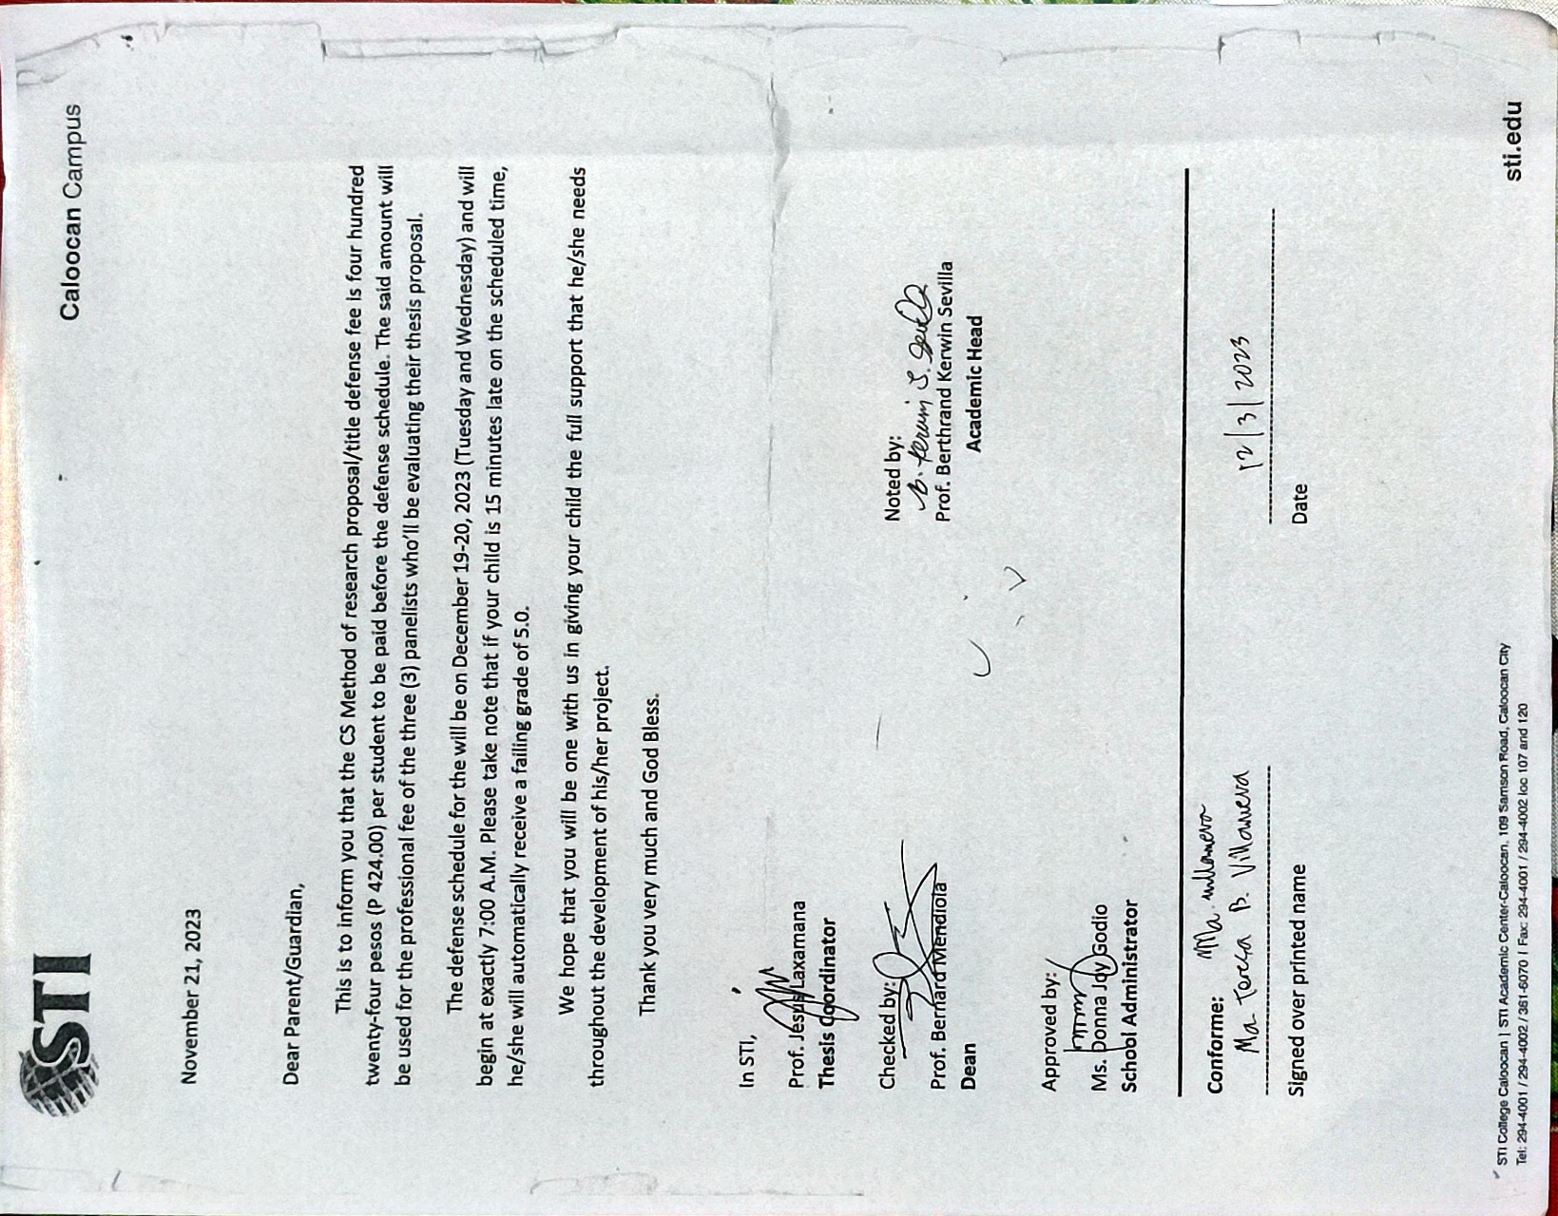

Appendix B: Accomplishment and Consultation Form

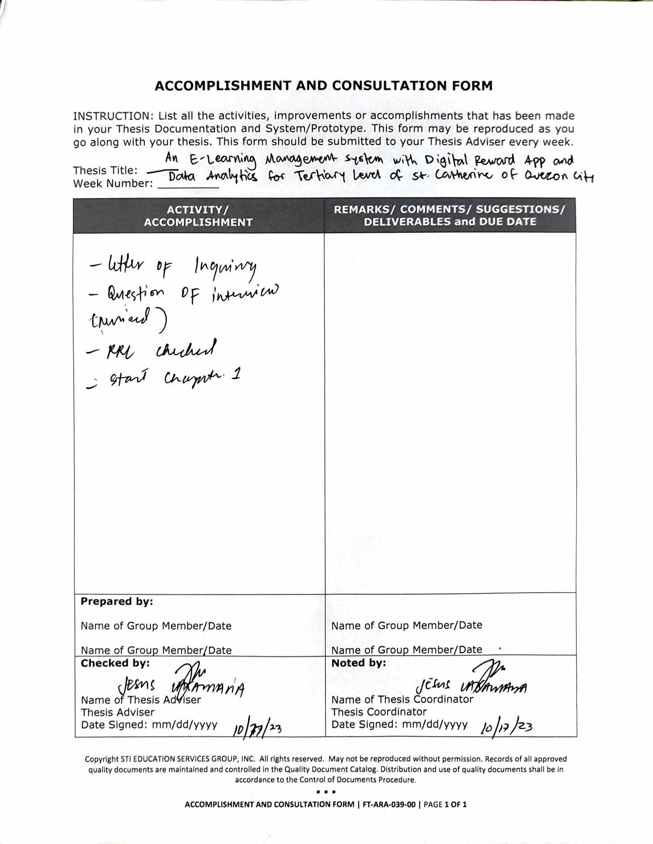

Appendix C: Diagrams

Data Flow Diagram

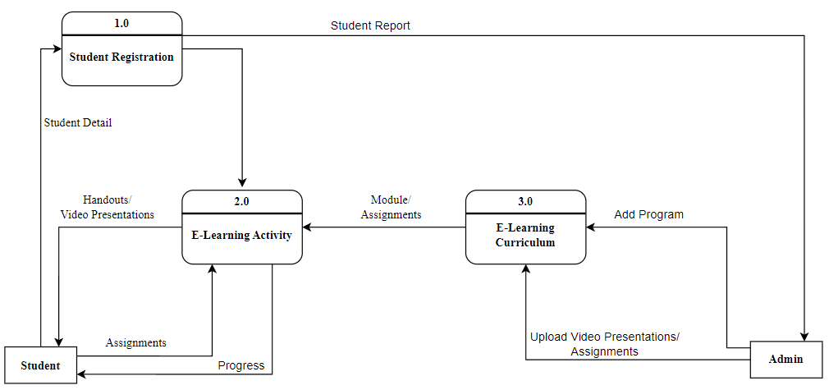

*Figure 3. Data Flow Diagram*

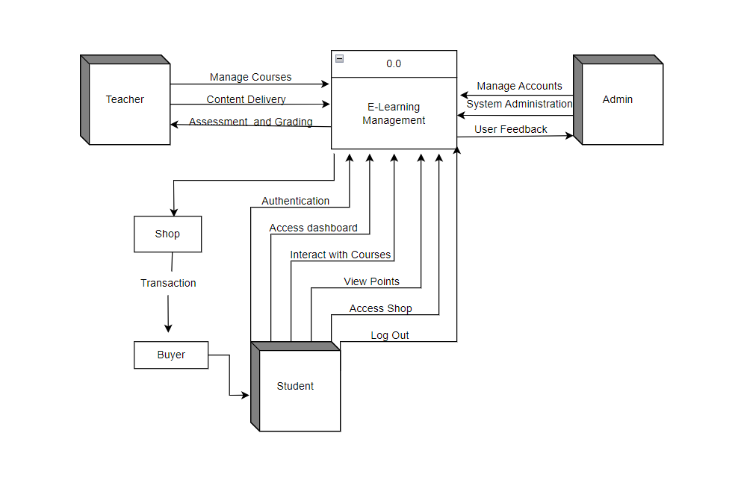Cumulative Flow Diagram

*Figure 4. Cumulative Flow Diagram*

Flowchart

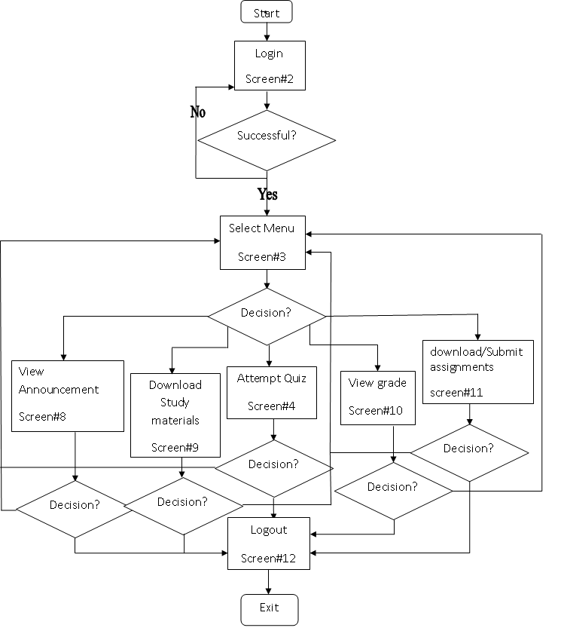

*Figure 5. Flowchart*

Entity Relationship Diagram

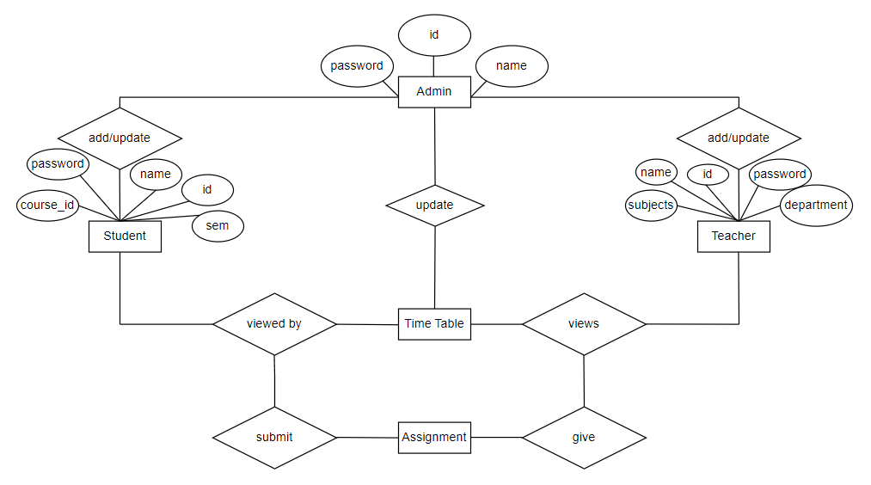

*Figure 6. Entity Relationship Diagram*

HIPO Diagram

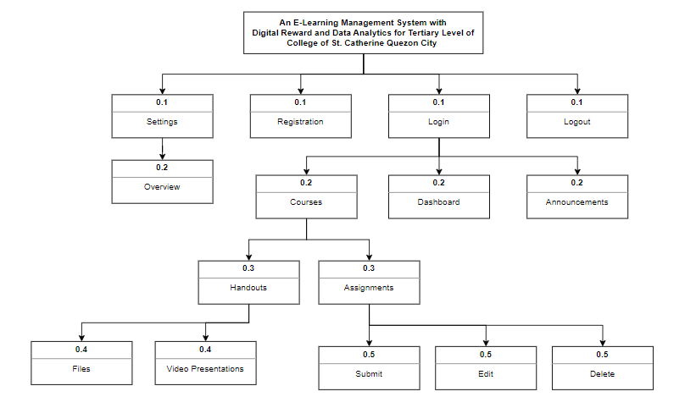

*Figure 7. HIPO Diagram*

Appendix D: Wireframe

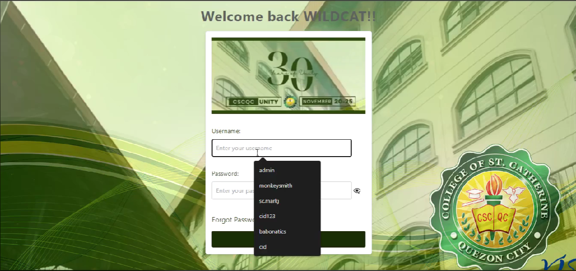

*Figure 8. Login Page*

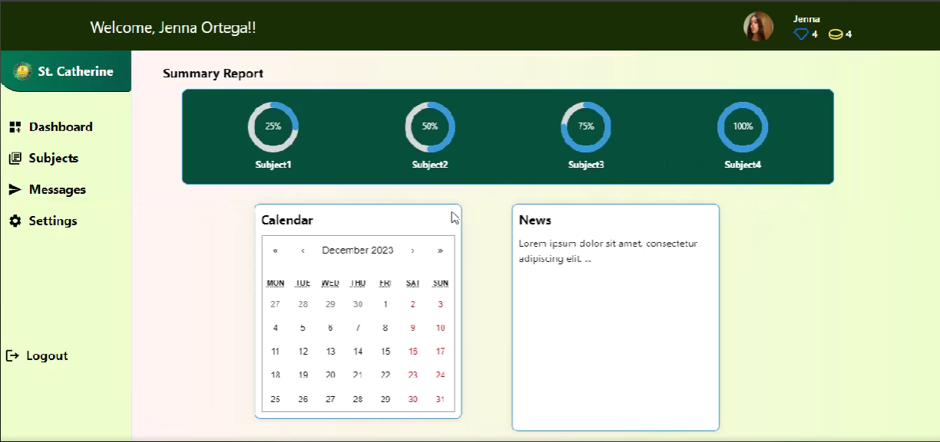

*Figure 9. Dashboard*

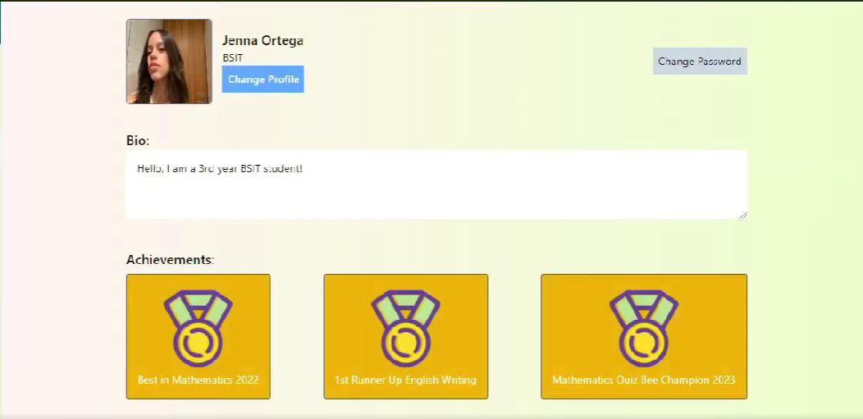

*Figure 10. Profile*

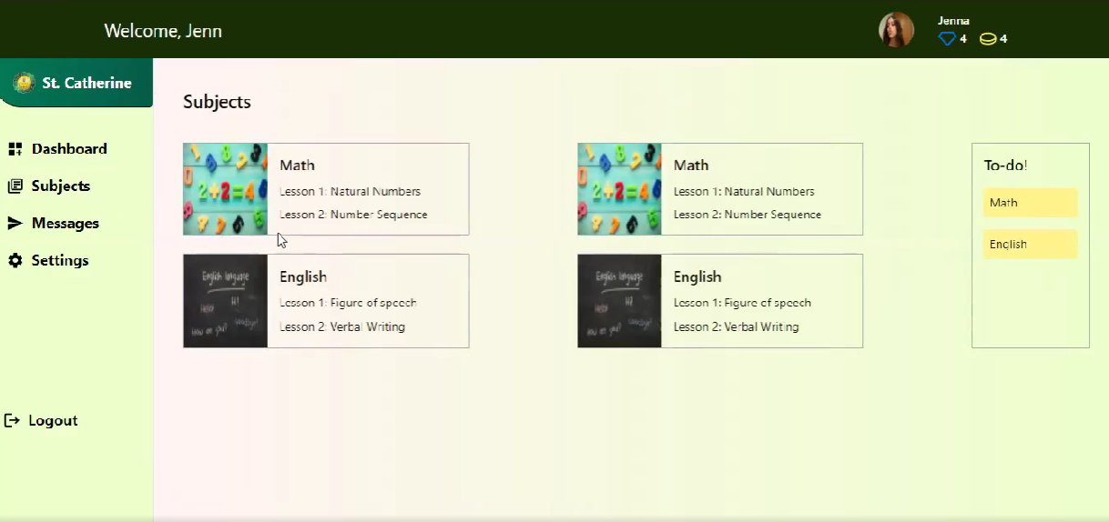

*Figure 11. Subjects*

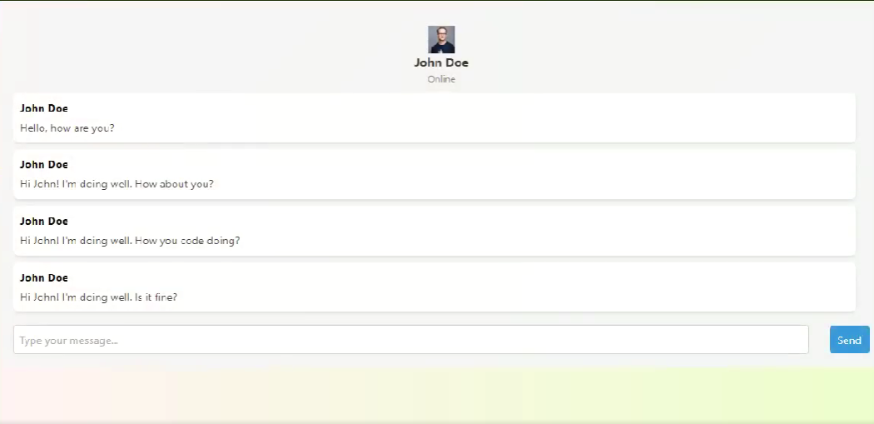

*Figure 12. Messages*

**

*Figure 13. Announcements*

**

*Figure 14. Logout*

APPENDICES (E): SURVEY

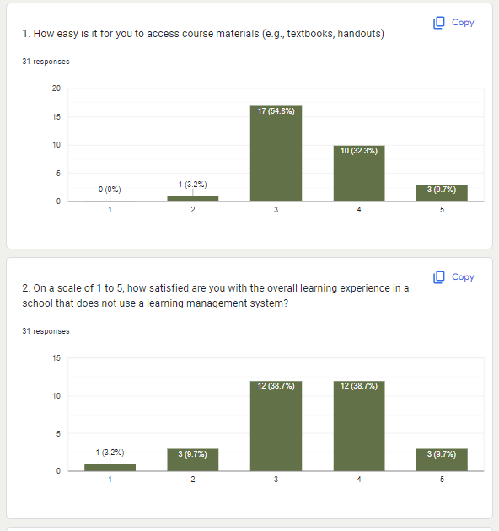

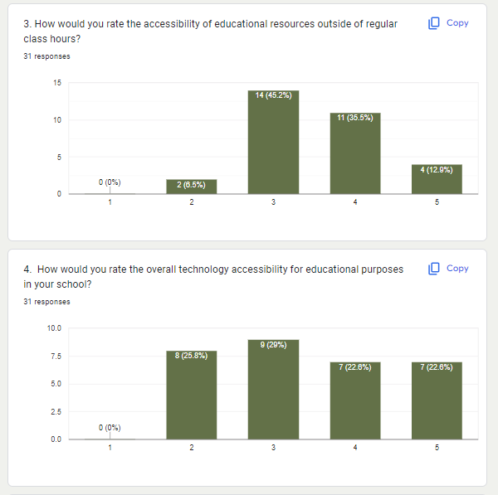

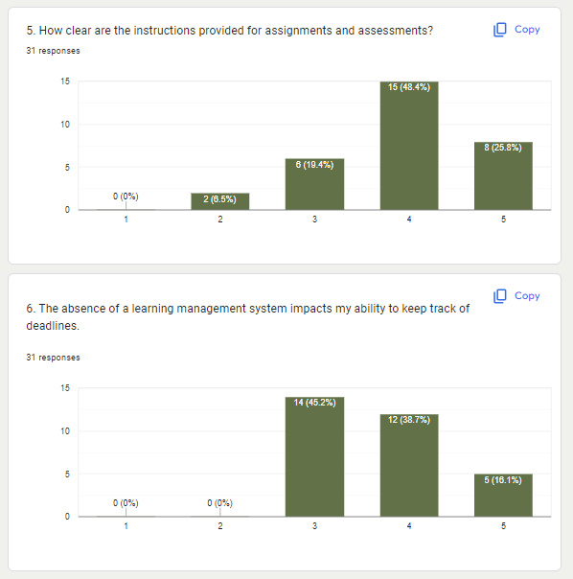

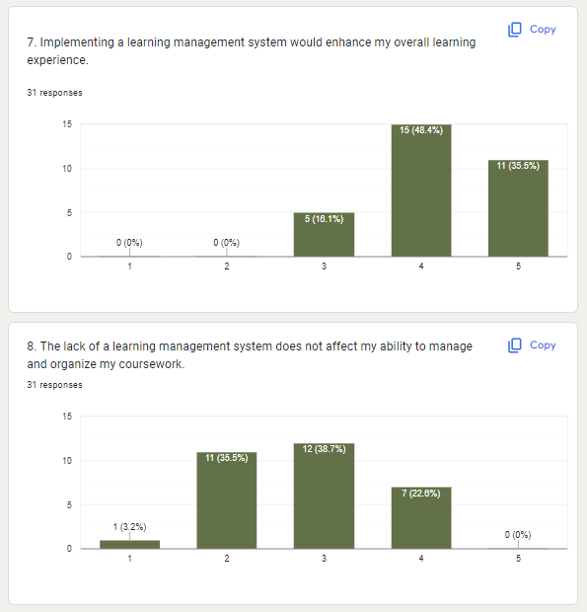

*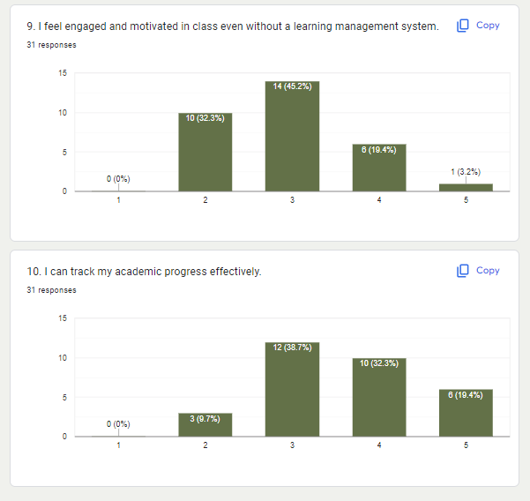Figure 15. Survey*